# STUDENT INTERNSHIP PROGRAM (SIP)

# REPORT

## 

**MIT Academy of Engineering**

**Submitted By**

**Malay Patil**

**T194070**

**0120170379**

##### SCHOOL OF COMPUTER ENGINEERING AND TECHNOLOGY

MIT ACADEMY OF ENGINEERING

ALANDI (D), PUNE

CERTIFICATE

This is to certify that the “**Student Internship Program (SIP)” report** submitted by Malay Patil **PRN 0120170379** is work done by him and is submittedduring 2019-2020 academic year.

**Faculty Mentor School - Internship Coordinator**

**(Mr. Pranav Shriram) (Nilesh Bhandari)**

**School Dean**

**(Mrs. Ranjana Badare)**

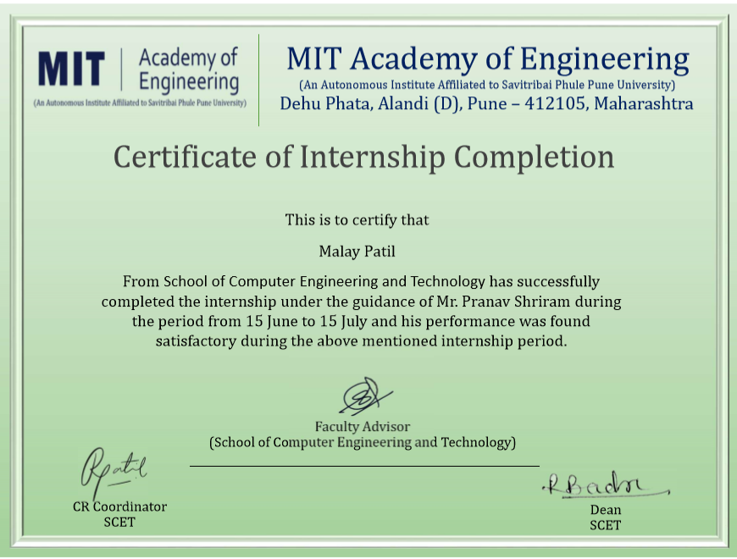

###### ACKNOWLEDGEMENT

I would like to take this opportunity to express my gratitude towards my guide Mr. Pranav Shriram for his constant encouragement, guidance and inspiration to aspire for best. I would like to thank Dean of SCET Mrs. Ranjana Badre Madam and all the staff member of School of Computer Engineering and Technology to give a chance to aspire internship.

**Malay Patil**

## Table of Contents

|  |  |  |  |
| --- | --- | --- | --- |
| **Topic** | | | **Page No.** |
| 1. | **Introduction** | | 6 |
|  | 1.1  1.2 | Overview  Problem Statement | 6  6 |
|  | 1.3 | Scope of Work | 6 |
| 2. | **Internship Discussion** | | 7 |
|  | 2.1 | Work Done | 7 |
|  | 2.2 | Methodology | 7 |
|  | 2.3 | Learning Experience | 18 |
|  | 2.4 | Future scope | 18 |
| 3. | **Conclusion** | | 19 |
| 4. | **Bibliography** | | 20 |

**INTRODUCTION**

* 1. **Overview**

This project is done in-house guided by Mr. Pranav Shriram in MIT Academy of Engineering(MITAOE) MITAOEis an Autonomous Engineering college Affiliated with the Savitribai Phule Pune Universit. It was Established in the year 1999 and is approved and accredited by [AICTE](https://en.wikipedia.org/wiki/AICTE).

Start Date : 15 June 2020

End Date : 15 July 2020

* 1. **Scope Of Work**
* A python application capable of hiding an encrypted secret message inside an image.
* Information can be transferred secretly on unsecured networks.
  1. **Problem Statement:**
* Image Stenography:
  + The techniques for secret hiding of messages in an otherwise innocent looking carrier message belong to the field of steganography. The purpose of steganography is to conceal the very presence of secret information. To make the communication more secure, the secret information can be compressed and encrypted before it is hidden in the carrier. This is important because in this way we minimize the amount of information that is to be sent, and it is also easier to hide a random looking message into the carrier than to hide a message with a high degree of regularity. Encrypting the compressed message before hiding is recommended and provides double protection.

### **INTERNSHIP DISCUSSION**

### **2.1. Work done:**

week-1:

* encryption of message using base64
* study for PIL (python image library)

week-2:

* main page GUI development completed
* file handling
* completed upto hiding message function

week-3:

* decryption function created
* removed small bugs from frames

week-4:

* GUI completed.
* arranged code in classes for better understanding

### **2.2. Methodology:**

Images are made of digital pixels, every pixel describes the color of the image.this pixels contains 3 values (Red,Green and Blue). Every byte of data is converted to its 8-bit binary code using ASCII values.

for example the msg is “hii” . since the size of message is of 3 bytes pixel required to store data is 3x3=9 pixels. here ASCII value for H is 72 and binary is 01001000 now lets say the pixels data is (27,64,164) ,now change pixel to odd for 1 and even for 0 so the modified pixel will be (26,63,164). since we have to add more data so the last value has to be even.

now to decode the data pixels are read at a time, till last value is odd, which means the message is over. every 3 pixel contain a binary data which can be extracted by the same encoding logic.

“Bmessenger” allows users to select image of user’s choice and encrypt and hide the message inside image.

Software requirement:

1. python3 - coding language
2. libraries:
   * 1. PILLOW - pillow is a fork of PIL (Python Image Library) to perform diffrent operations like changing format, resolution, modifying pixels, etc.
     2. BASE64 - basse64 is python’s inbuilt library to convert normal msg into base64 encrypt format, base64 provides faster encryption and decryption.
     3. TKINTER - tkinter or tk is python library for creating GUIs (graphical user interface).

steps of project

* import all the required libraries in code:

import base64

from tkinter import *

from tkinter import ttk

from PIL import ImageTk

from PIL import Image

from io import BytesIO

import os

* the code is divided into 2 classes:

1. func - all the functions are in this class
2. frames - all the GUI frames are in this class

* class func consists of 7 functions :

1. e_path(self,ef) : function to select image to encode
2. e_fun(self,text_area,myimage,frame) : function to encrypt text in base64
3. encode_enc(self,newimg,data) : function to enter encrypted data into image and hide data.
4. modpix(self,pix,data) : sub function to be used in enocde_enc()
5. gendata(self,data) : function to convert data in binary
6. d_path(self,df) : function to select path of image to decode
7. decode(self,image) : function to decode data

* class frames consists of 4 frames of GUI code:

1. main(self,root) : main page of the application
2. encode_page(self,f) : frame for encode page
3. decode_page(salf,f) : frame for decode page
4. home(self,frame) : to call the main frame and destroy all old frames

code in brief:

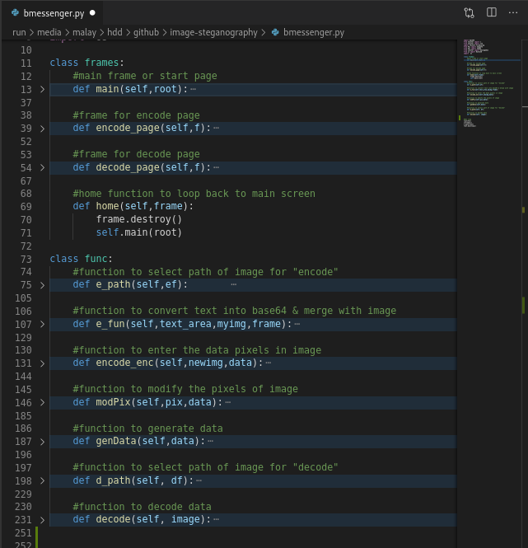

Results :

1. successfully hiding the data:

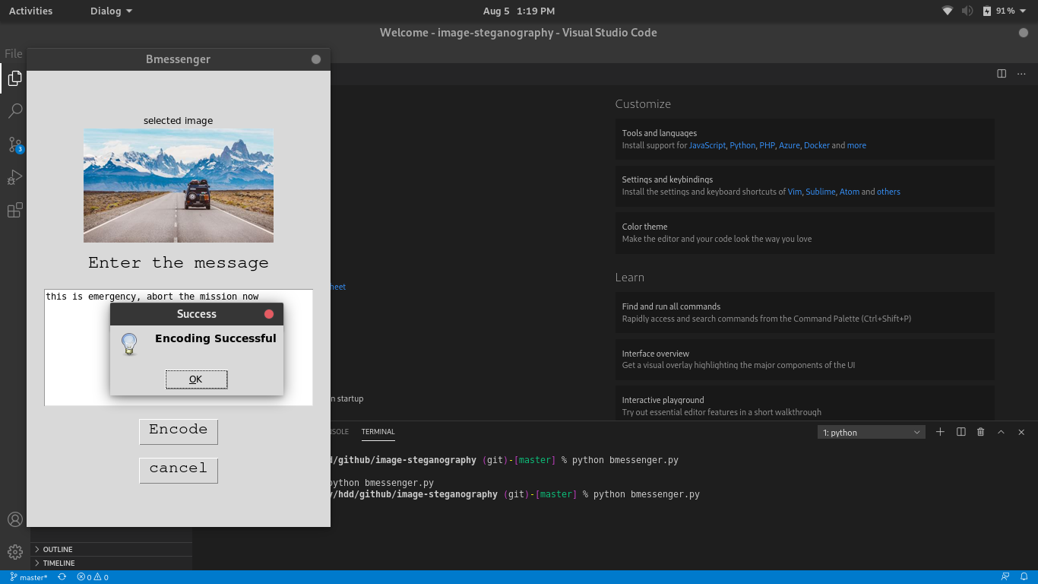

2)successfully reveal data:

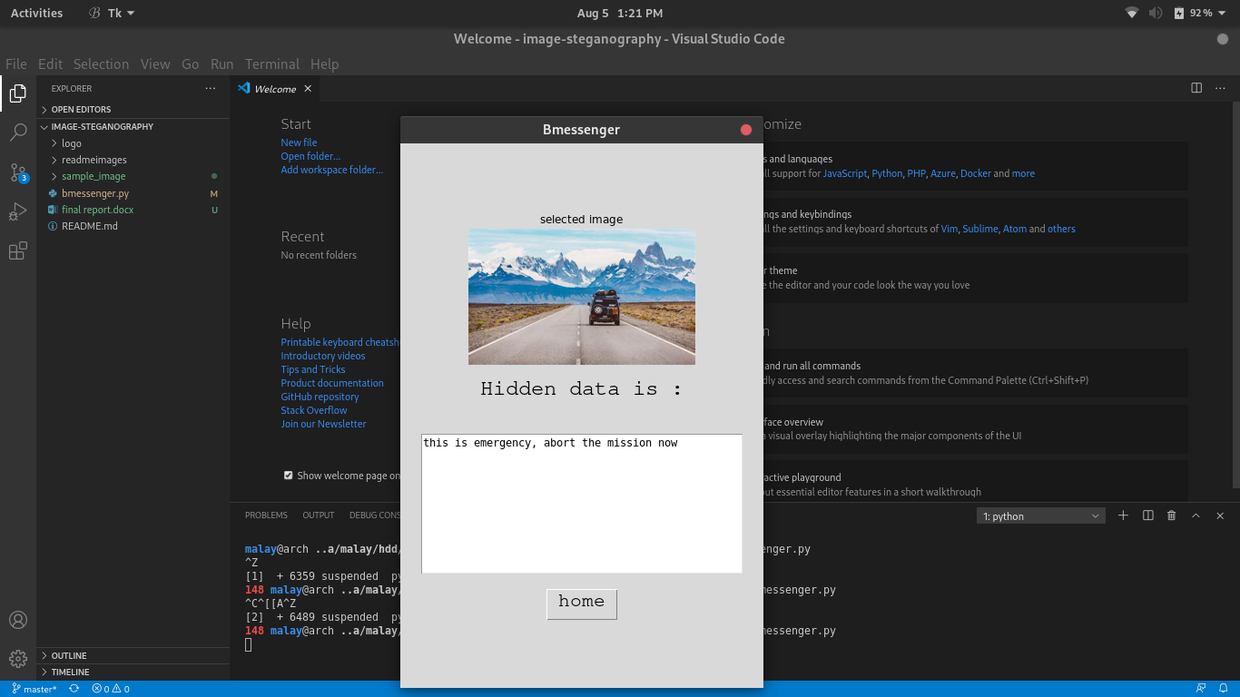

### **2.3. Learning Experience**

**2.3.1. Knowledge Acquired:**

By completing this project i have learned to work on images and i have gained information of how easily the pixel of image can be modified. I have also learned file handling as i have used image saving feature in this application, Tkinter is used in GUI part with different frames.

**2.3.2. Attitude and Values:**

I have gathered very useful knowledge while completing the project and i have learned professionalism such as following deadlines and completing work in time.

**2.3.4. Most difficult task:**

Managing frame was the most difficult task as i have never used GUI with python, the most annoying thing was to collect variables from 1 frame to another frame for me and alignment of every module in GUI. It almost took 3-4 days to work correctly.

**2.4 Future Scope:**

This application can be used in transferring messages through insecure networks. There are less chances of data leak as it is not possible to identify if the image is tempered if someone finds out the hidden data it is still hard to identify the encryption method so that it can be used to protect from data alteration attacks, man in the middle attack can be avoided. It can be used in intelligence agencies, smart identity card etc.

**CONCLUSION**

This project helped me to learn gui for application and also I have gathered knowledge of steganography and I understood how to implement it using python image library and also learned to construct code properly.

**BIBILOGRAPHY**

* <https://www.geeksforgeeks.org/image-based-steganography-using-python/>
* <https://docs.python.org/3/library/tkinter.html>
* <https://pillow.readthedocs.io/en/stable/>
* <https://docs.python.org/3/library/base64.html>